**Experiment / Assignment / Tutorial No. 2**

**Grade: AA / AB / BB / BC / CC / CD /DD**

**Signature of the Staff In-charge with date**

|  |
| --- |
| **Batch: B1 Roll No.: 1711072 Experiment / assignment / tutorial No.: 2** |

|  |
| --- |
| **Title:** Binary Adders and Subtractors |

**_____________________________________________________________________________________**

**Objective:** To implement half and full adder–subtractor using gates and IC 7483

**______________________________________________________________________**________

**Expected Outcome of Experiment:**

**CO2:** Use different minimization technique and solve combinational circuits, synchronous & asynchronous sequential circuits.

**______________________________________________________________________________**

**Books/ Journals/ Websites referred:**

* R. P. Jain, “Modern Digital Electronics”, Tata McGraw Hill
* M .Morris Mano, “Digital Logic & computer Design”, PHI
* http://physics.niser.ac.in/labmanuals/sem5/elect/7_ADDER%20SUBTRACTO  [R%20CIRCUITS.pd](http://physics.niser.ac.in/labmanuals/sem5/elect/7_ADDER%20SUBTRACTOR%20CIRCUITS.pdf)f

**Pre Lab/ Prior Concepts:**

**Adder:** Addition of two binary digits is most basic operation performed by the digital computer. There are two types of adder:

* Half adder
* Full adder

**Half Adder:** Half adder is combinational logic circuit with two inputs and two outputs. It is the basic building block for addition of two single bit numbers.

**Full adder:** A half adder has a provision not to add a carry coming from the lower order bits when multi bit addition is performed. for this purpose a third input terminal is added and this circuits is to add A,B,C where A and B are the nth order bits of the number A and B respectively and C is the carry generated from the addition of (n-1) order bits. This circuit is referred to as full adder.

**Subtractor:** Subtraction of two binary digits is one of the most basic operations performed by digital computer .there are two types of subtractor:

* Half subtractor
* Full subtractor

**Half subtractor:** Logic circuit for the subtraction of B from A where A,B are 1 bit numbers is referred to as half subtract or .the subtract or process has two input and difference and borrow are the two outputs.

**Full subtractor:** As in the case of the addition using logic gates, a full subtractor is made by combining two half-sub tractors and an additional OR-gate. A full subtractor has the borrow in capability (denoted as BORIN) and so allows cascading which results in the possibility of multi-bit subtraction.

**IC 7483**

For subtraction of one binary number from another, we do so by adding 2’s complement of the former to the latter number using a full adder circuit.

IC 7483 is a 16 pin, 4-bit full adder. This IC has a provision to add the carry output to transfer and end around carry output using Co and C4 respectively.

**2’s complement:** 2’s complement of any binary no. can be obtained by adding 1 in 1’scomplement of that no.

e.g. 2’s complement of +(10)10 =1010is

|  |  |  |  |
| --- | --- | --- | --- |
| 1C of 1010 |  | | 0101 |
|  |  | + | 1 |
| -(10)10 |  | | 0110 |

In 2’s complement subtraction using IC 7483, we are representing negative number in 2’s complement form and then adding it with 1st number.

**Implementation Details:**

**Half Adder Block Diagram**

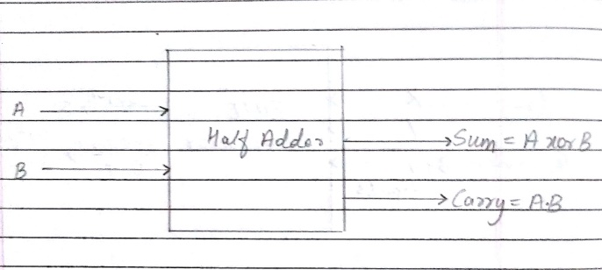

**Half Adder Circuit**

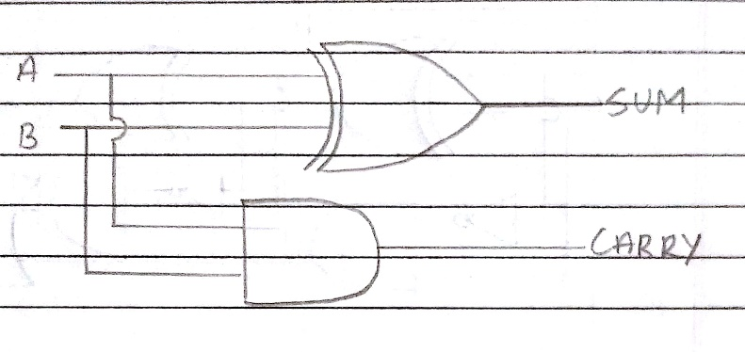

**Truth Table for Half Adder**

|  |  |  |  |
| --- | --- | --- | --- |
| **Inputs** | | **Outputs** | |
| **A** | **B** | **S** | **C** |
| 0 | 0 | 0 | 0 |
| 0 | 1 | 1 | 0 |
| 1 | 0 | 1 | 0 |
| 1 | 1 | 0 | 1 |

**From the truth table (with steps):**

**S=A.B’+A’.B**

**C=A.B**

**Full Adder Block Diagram**

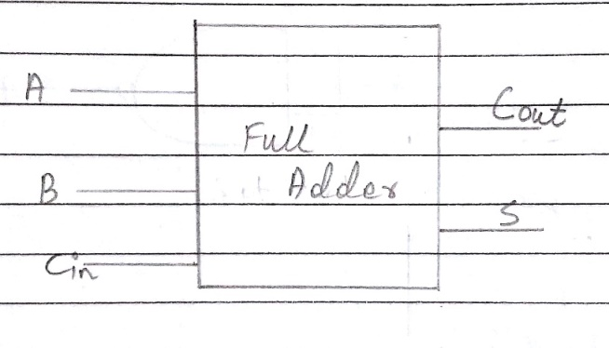

**Full Adder Circuit**

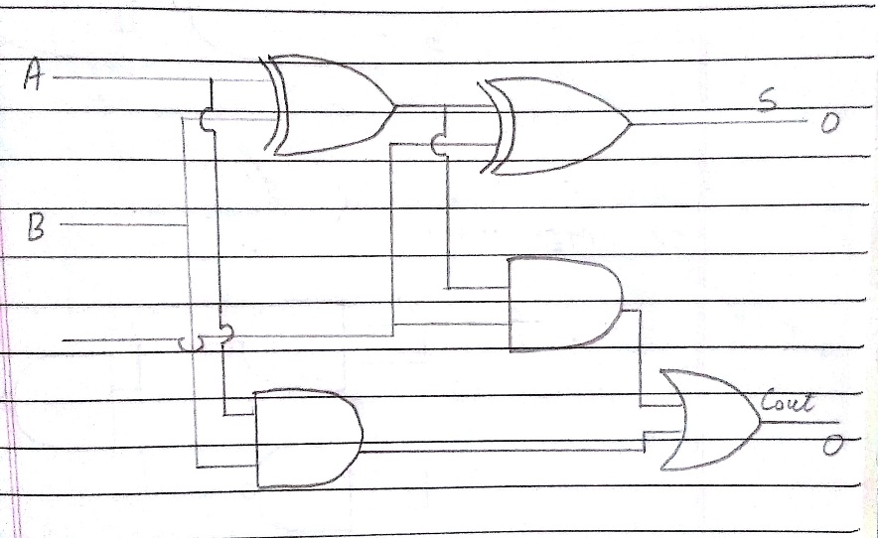

**Truth Table for Full Adder**

|  |  |  |  |  |
| --- | --- | --- | --- | --- |
| **A** | **B** | **C** | **Sum** | **Carry** |
| 0 | 0 | 0 | 0 | 0 |
| 0 | 0 | 1 | 1 | 0 |
| 0 | 1 | 0 | 1 | 0 |
| 0 | 1 | 1 | 0 | 1 |
| 1 | 0 | 0 | 1 | 0 |
| 1 | 0 | 1 | 0 | 1 |
| 1 | 1 | 0 | 0 | 1 |
| 1 | 1 | 1 | 1 | 1 |

**From the truth table (with steps):**

**S=A’.B’.Cin+A’.B.Cin’+A.B’.Cin’+A.B.Cin**

**Cout(Carry) =A.Cin+A.B+B.Cin**



**Half Subtractor Block Diagram**

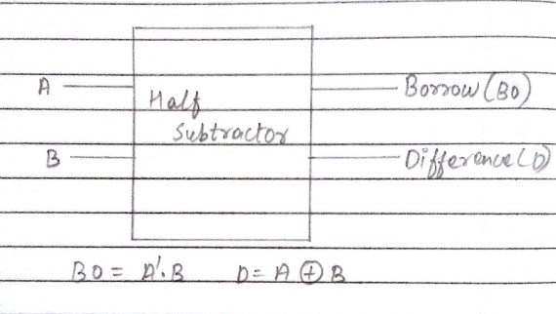

**Half Subtractor Circuit**

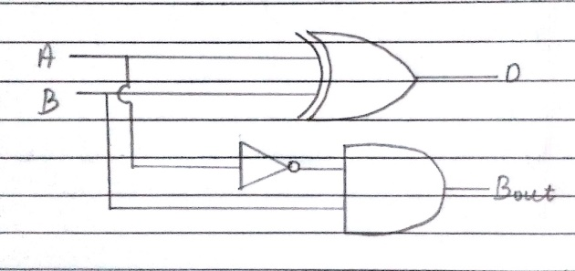

**Truth Table for Half Subtractor**

|  |  |  |  |  |
| --- | --- | --- | --- | --- |
|  |  |  |  |  |
| **A** | **B** | **DIFFERENCE(D)** | **BORROW(Bo)** |
|  |  |  |  |
| 0 | 0 | 0 | 0 |
|  |  |  |  |
| 0 | 1 | 1 | 1 |
|  |  |  |  |
| 1 | 0 | 1 | 0 |
|  |  |  |  |
| 1 | 1 | 0 | 0 |
|  |  |  |  |

**From the truth table (with steps) :**

**Difference(D)=A’.B+A.B’**

**Borrow(Bo)=A’.B**

**Full Subtractor Block Diagram**

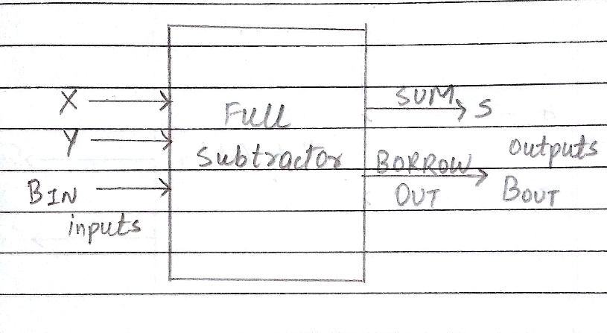

**Full Subtractor Circuit**

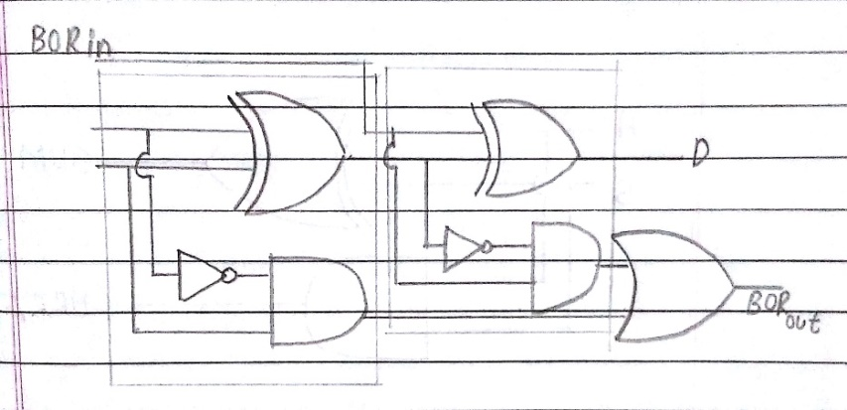

**Truth Table for Full subtractor:**

|  |  |  |  |  |
| --- | --- | --- | --- | --- |
| **A** | **B** | **BIN** | **D** | **BOROUT** |
|  |  |  |  |  |
| 0 | 0 | 0 | 0 | 0 |
|  |  |  |  |  |
| 0 | 0 | 1 | 1 | 1 |
|  |  |  |  |  |
| 0 | 1 | 0 | 1 | 1 |
|  |  |  |  |  |
| 0 | 1 | 1 | 0 | 1 |
|  |  |  |  |  |
| 1 | 0 | 0 | 1 | 0 |
|  |  |  |  |  |
| 1 | 0 | 1 | 0 | 0 |
|  |  |  |  |  |
| 1 | 1 | 0 | 0 | 0 |
|  |  |  |  | 1 |
| 1 | 1 | 1 | 1 | 1 |
|  |  |  |  |  |

**From the truth table (with steps):**

**Difference (D)=A’.B’.Bin+A’.B.Bin’+A.B’.Bin’+A.B.Bin**

**BORout=A’.B+A’.Bin+B.Bin**

**IC 7483**

**Procedure:**

1. Locate the IC 7483 and 4-not gates block on trainer kit.
2. Connect 1st input no. to A4-A1 input slot and 2nd (negative) no. to B4-B1 through 4-not gates (1C of 2nd no.)
3. Connect high input to C0 so that it will get added with 1C of 2nd no. to get 2C.
4. Connect 4-bit output to the output indicators.
5. Switch ON the power supply and monitor the output for various input combinations.

**Example:**

|  |  |  |
| --- | --- | --- |
| 1) 710 -210 = 510 | |  |
| 7 |  | 0111 |
| 2 |  | 0010 |
| 1’C of 2 | | 1101 |
|  |  | + 1 |
| 2’C of 2 | | 1110 |

0111

+ 1110 0101

**Pin Diagram IC7483**

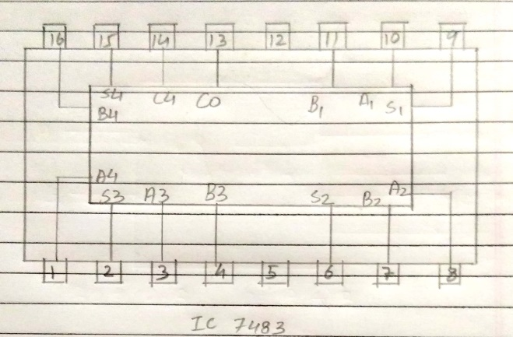

**Adder**

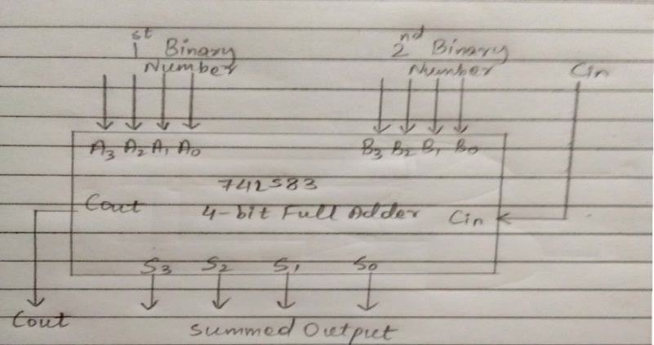

**Subtractor**

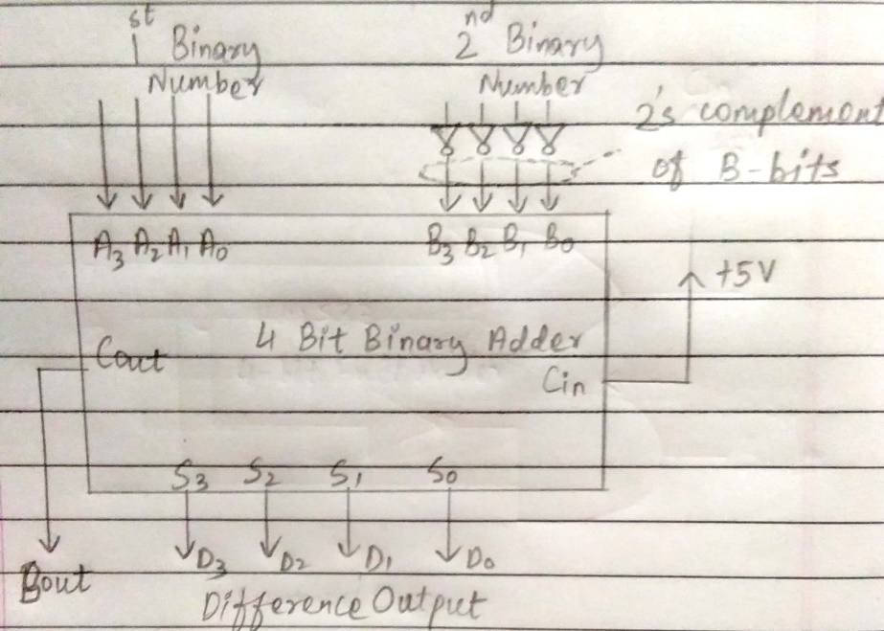

**Post Lab Descriptive Questions:**

1. What is difference between half and full adder, half and full subtractor?

Ans. **Full adder and half adder:**

The difference between half adder and full adder is that full adder has three inputs and two outputs. The two inputs are A and Band the third is a carry input Cin.The output carry is designated as Cout and the normal output is designated as S whereas half adder has two inputs and one output and carry is neglected in half adder. It isn’t neglected in full adder.

**Full subtractor and half adder:**

The difference between half subtractor and half subtractor is also the same. Half subtractor has two inputs and one output while full subtractor has 3 inputs and 2 outputs and bits are borrowed in full subtractor. It is not restricted to one bit subtraction.

1. Perform the following Binary subtraction with the help of appropriate ICs:
2. 7-5
3. 5-7
4. 9-4

Ans. a) The binary form of 7 is:0111

The binary form of 5 is: 0101

1’s complement of 5 is:1010

+ 1

2’s complement of 5 is:1011

Thus 7-5 is:

0111

+1011

(0010)2 = (2)10

b) The binary form of 5 is: 0101

   The binary form of 7 is: 0111

1’s complement of 7 is: 1000

                                   + 1

2’s complement of 7 is: 1001

Thus 5-7 is:

                    0101

                  +1001

                   (1110)2

The answer is a negative number. Hence we take the 2’s complement

1’s complement: 0001

                          +1

2’s complement: (0010)2= (2)10

1. The binary form of 9 is:1001

  The binary form of 4 is: 0100

1’s complement of 4 is: 1011

                                    + 1

2’s complement of 4 is: 1100

Thus 9-4 is:

                    1001

                  +1100

                   (0101)2 = (5)10

**Conclusion:**

The binary circuit for half/full adder and subtractor were studied by both basic gates and dedicated gates for various test cases with correct outputs.